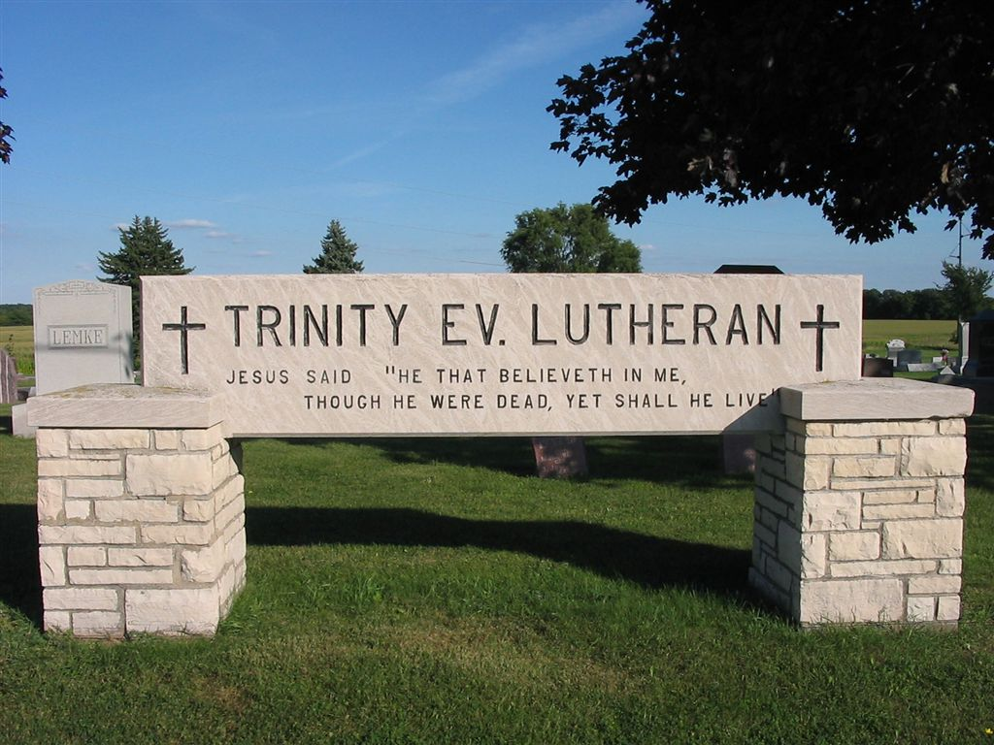

Trinity Ev. Lutheran Church and Cemetery
920-766-3929 or 920-766-2029
trinitykaukauna.com
Church: 804 Grignon Street
Kaukauna, WI 54130
Cemetery: W1239 State Road 96
Kaukauna, WI 54130

Official Rules and Regulations of the
Trinity Evangelical Lutheran Church Cemetery
of Kaukauna, WI
revision 2022.05.5
PART l
- The Cemetery is hereby established, and its duly elected committee is authorized to operate Trinity Evangelical Lutheran Church Cemetery.
- The Cemetery Committee shall report to the Executive Board twice per year. This meeting shall cover membership changes and general business. New proposed Committee members shall be recommended by the Cemetery Committee and approved by the Executive Board.
- The Committee shall consist of a president, a vice-president, and three additional board members. Each member of the Committee shall be elected for a staggered five-year term.
- The secretary/treasurer shall be elected by and from the Cemetery Committee members.
- The Committee shall meet prior to the Annual Congregational Meeting to approve and submit the annual report of the Church’s Cemetery Committee at that congregational meeting, and shall have at least three (3) additional meetings throughout the year as called by the president.
- The Cemetery Committee shall supervise and establish two separate funds:
  - All money received from interest earned on the cemetery fund, receipts from the county for care of veteran graves, permit fees, sale of old equipment and all donations given to the cemetery, shall be deposited into a general Operating Fund. The Committee shall report all disbursements for operating and maintaining of the cemetery.
  - All mandated money received from the sale of grave sites (15% of the purchase price of grave sites according to State of WI statute in 1991 ) and all invested funds reported shall be recorded according to state laws and be deposited into a Perpetual Care Fund.
  - These cemetery funds shall always be kept separate, and distinct from all other congregational funds. At no time shall any of these funds be used other than for cemetery purposes.
- The Cemetery Committee shall have the authority to establish rules and regulations for the cemetery, from time to time as deemed wise for the proper care and protection of the cemetery and its grounds.

Part ll.
- No one other than the official grave digger hired by the Cemetery Committee, or the Committee members is authorized to dig grave sites.
- A permit to erect a monument must first be obtained from the Cemetery Committee. The size of the monument permitted is as follows:
  - Materials – Markers shall be constructed of granite, marble or bronze. No other materials will be permitted.
  - Single Grave Surface Markers – Each single marker shall consist of one flat piece only and shall not exceed 30” in length, 24” in width and shall not be less than 3 ½” thick or more than 5” thick.
c. Double Grave Surface Markers – Each double marker shall consist of one piece only and shall not exceed 48” in length, 24” in width and shall be no less than 3 ½” thick or more than 5” thick.
d. Headstone Grave Markers – Headstones for single or double grave markers shall follow the previous length and width maximums. Height shall be limited to 40” in height. The bottom bed of all markers and all joints must be cut level and true so that all parts are in perfect contact.
e. Monuments – The dimensions of each monument shall be primarily governed by sound engineering and design principles, except that, the base of any monument shall not exceed ½ of the width of the plot; the height of the monument for two grave sites shall not exceed 40 total inches, and the height of the monument for three or more grave lots shall not exceed 40”. The bottom bed of all monuments and all joints must be cut level and true so that all parts are in perfect contact.
f. Columbariums – Columbariums for single or double grave markers shall follow the previous length maximums. Height shall be limited to 40” in height. The bottom bed of all markers and all joints must be cut level and true so that all parts are in perfect contact.
- Permit for a Veteran Plaque need not be obtained for its creation. However, a cemetery representative must be present for its installation.
- A concrete or metal burial vault is required for all burials except cremains.
- No burial shall take place, or any monument, headstone, columbarium or marker shall be erected until the site or plot is fully paid.
- The cemetery is not responsible for any damage to monument, headstone, columbarium or marker. The site or plot owner may insure his monument, headstone, columbarium or marker under his homeowner’s insurance policy, and is recommended to do so.
- The cemetery will offer year-round burials with the following conditions:
a. When doing a winter burial, we must also be mindful of the adverse conditions which might exist for those who would be attending the burial service. Since cemetery authorities are in charge of the procession once it enters the cemetery, a decision must be made of whether or not the conditions are safe enough for people to get out of their cars and walk to the grave. Care must be taken to ensure that there are no injuries due to slippery conditions in the cemetery. A burial may be denied if the person in charge of the cemetery deems the burial to be impractical. It is important that a written record be made briefly stating the reason for the denial – and signed by the person in charge of the cemetery. A copy of the “Impracticability Agreement” must be kept on file.
b. The family is not required to choose a winter burial. The family does have the option to choose a burial at a later date. If the family chooses a burial at a later date, the “Waiver of Right to a Winter Burial” form must be signed by the family and kept on file.
c. When a family chooses a winter burial, they must sign the “Hold Harmless” document. This document will protect the cemetery in case of an error when accomplishing the winter burial. It will protect the cemetery in case of an error or damage when accomplishing the winter burial. This form must be signed by the family and kept on file.
d. A fair additional charge for winter burial may be justified. Items to take into consideration for additional charge are as follows:
    - Snow removal into the cemetery and to the grave site
    - Defrosting the burial site to include the cost of the thawing device
    - Additional charges for difficulty/day/time of the site preparation and repair
    - Repairing the grave site in the spring (topsoil and sod or seed) and any damage done to the grounds to get to the burial space.
8. The cost of a site, of opening and closing graves, and perpetual care are all determined by the Cemetery Committee and are listed in this book.
9. Any decorations for Memorial Day must be suspended from the headstone – out of the way for lawn mowing and trimming purposes. Any potted plants or floral bouquets may be placed about the headstones for one week only – the week of Memorial Day – and then must be removed. The Cemetery Committee reserves the right to restrict and/or remove any effects/decorations/markers contrary to Rules and Regulations of the cemetery.
10. A site owner must notify the Cemetery Committee for approval of a burial and/or a monument placement.
11. Extra grave sites may be purchased in aisles abutting a family plot – (42” in width and platted length of site) but all applicants must first secure consent of abutting or adjoining lot owner, for one grave width only. (Aisle sites will be in direction of Hwy 96 to river – not crosswise).
12. Funeral Director shall contact the Cemetery Committee 48 hours prior to intended burial.
13. The maximum cremation burials on a single grave site shall be limited to two burials. Only one headstone marker will be allowed. An additional surface flush mounted marker will be allowed.

14. Fees: subject to change. Effective 7-1-2021
Sale of Grave Sites: $ 1000 each
Burial fees (site work): $ 1000
Cremation Burial (Urn): $ 500 (+ prep costs)
Marker Permit Fee: $ 10

Part lll
- Secretary/Treasurer shall notify the Funeral Director in writing of the determined current burial charge.
- All monuments shall be kept in good repair at cost to the lot owner.
- No pets allowed. Service animals are allowed for patrons who carry the certificate. Animals shall remain leashed at all times and patron is responsible for any cleanup after the animal.
- The use of firearms within the cemetery is strictly forbidden, except for military honors.
- Any improvements in the cemetery grounds, lots, or graves including the planting of any living vegetation are subject to the control and direction of the Cemetery Committee.
- Snow plowing or snow removal will not be permitted; this is to prevent possible damage to grave sites or grave markers. Snow removal will be permitted in case of an allowed winter burial at the direction of the Cemetery Committee.

. . . . . .

Bylaws of
Trinity Ev. Lutheran Church
(Which authorize the formation and governance
of the Cemetery Committee)

Section 3: Cemetery Committee.
- The Cemetery Committee is established and authorized to operate Trinity Evangelical Lutheran Church Cemetery.
- The Cemetery Committee shall report to the Executive Board twice per year. This meeting shall cover membership changes and general business. New Committee members shall be recommended by the Cemetery Committee and approved by the Executive Board.
- The Cemetery Committee shall consist of a president, a vice-president, and three additional board members each for a five-year staggered term.
- The secretary-treasurer shall be elected by the Cemetery Committee.
- The Cemetery Committee shall present an annual report at the Annual Voters’ Meeting.
- The Cemetery Committee shall supervise and establish two separate financial funds:
  - A general Operating Fund wherein shall be deposited all receipts from interest earned on the cemetery funds, receipts from the county for care of veteran graves, permit fees, and sale of old equipment and all donations given to the cemetery, etc. It shall report all disbursements for operating and maintaining of the cemetery.
  - It shall establish a Perpetual Care Fund wherein all moneys received from the sale of grave sites, all invested funds reported, etc. shall be recorded according to state laws.
  - These cemetery funds shall always be kept separate and distinct from all other congregational funds. At no time shall these funds be used other than for cemetery purposes.
- The Cemetery Committee shall have the authority to establish rules and regulations for the cemetery, from time to time, as deemed wise for the proper care and protection of the cemetery and its grounds.

2021 Cemetery Board
Rev. Roger Holtz, President - 2024
Mr. Don Barker, Vice President - 2025
Ms. Cindy Weiland, Secretary/Treasurer - 2026
Mrs. Lynne Collins, member - 2023
Mr. Oliver Kruse, member - 2022
(designated year signifies term of office through 12/31 of the given year)

